OctoFlex Technologies Inc. (Software Process Model)

Submitted by:

Mihirkumar Dilipbhai Patel

Table of Contents

Page No.

1. Executive Summary 3
2. Introduction to the Idea 4
   * Description of a particular ongoing project
   * Goals and Introduction to the idea of using a development approach
3. Description on Design and Development Model 5-7
4. Why Agile Development Model? 8-9
5. Conclusion 10
6. Bibliography 11-12

# Executive Summary

OctoFlex Technologies is a start-up IT firm that is focused on fulfilling all the needs of the businesses. We provide services to small- and medium-sized companies. With experienced professionals and a team approach to most of the projects, OctoFlex Technologies will be able to offer a more balanced quality services than many of its competitors in the market.

## The Company

OctoFlex Technologies is a team of two IT professional. Each professional specializes in some particular discipline and has broad knowledge of other disciplines as well.

OctoFlex Technologies offers many services for business owners to select from, depending on their individual needs. This includes developing a website or application on any platform for any buisness.

## The Market

OctoFlex Technologies promises to provide the best service and customer experience. Its main goal is to fulfill all the needs of its customers. OctoFlex Technologies assures that the final product that it will develop will be of good value.

## Ongoing Major Project

OctoFlex is currently working on Blood Support+ which is a mobile application software for blood donation and receiver. This software will be developed to showcase the skills and built trust on our IT professional. Later, when this application will be released in support of people in need of blood or its components.

## Introduction to the Idea of developing a Blood Support+ Application

Blood donation is an invaluable gift that a person can give to some other person. It is a gift for lifetime. There is always a need for blood supply because blood can be stored for only a short period before it is used. There is always a need for blood by women with complications during their pregnancy and childbirth. We never know when someone needs blood. Some people might need blood essentially any time for their surgeries, treatments, and traumatic injuries. The person might need the whole blood or just some of the components of the blood such as plasma, red blood cells, white blood cells or platelets.

With the fast growth of usage of social networking sites among people, it is observed that there is also an increase in request from various people for blood donation. Many people keep a post on the social networking sites such as Twitter, Instagram, Facebook looking for blood donors. It is definitely a challenge for people in need to find a blood donor in short time when they need the blood the most which can happen anytime because nobody knows what happens next. It is observed that some new software applications have been developed by different developers to find people who are willingly ready for blood donation.

People will only go for the software applications which is more reliable and trustworthy. People will go for the application which meets all their requirements. For that reason, we will discuss our companies’ idea for design and development of the software applications. Our main goal is to design and develop the software applications with proper documentation in as short time as it could be with absolute correctness so that there would not be any kind of errors or bugs in future. Below is the description of the software model that our company will approach in developing different software.

# Description on Design and Development Model

The best approach for the software design and development that many companies from small scale to large scale use nowadays is the Agile Approach. Agile Methodology uses an iterative approach for development of a software. Agile project is wholly a combination of number of small cycles called sprints. Each of this sprint is a miniature which consists of all the design, development, testing and deployment phase. At the end of each sprint, the final product will be delivered to the client. The feedbacks from the client would be taken to add new features in every iteration until all the requirements of the client is met.

We have rationalized the whole process for the design and development of the software application using the Agile Approach based on the requirements that the client needs.

1. Gathering and analysing the client requirements

In this phase, a meeting will be set up with the client to determine the scope of the project. If there are numerous projects, then the one which is most important will be prioritized. The least important one will come at last. All the requirements that the client needs to be there in the application will be discussed and a proper documentation for the same will be prepared to outline them. There will be an attempt to put the requirements in the initial phase of the software development at minimum as these requirements will be added later. All the critical functionality of the application will be collected. The estimation of price and time will be made and shown to the client. This planning on analysing will help in deciding whether the project is feasible before any further development takes place.

1. Design Phase

After all the requirements have been highlighted, we will gather all the necessary tools and resources and the best people of our team to start the

design process. We will first build a software architecture and the simulation of the user interface. Application wireframe, prototype design, UX/UI design will be created that will provide the best user experience to the end-user. Further information on the requirements that the client needs will be taken to various UML diagrams for various stakeholders of the software application to determine the overall functionality. Regular meetings with the stakeholders will scheduled to ensure all the requirements are used in the design process of the application.

1. Development Phase

In this phase, we will first be working on front-end development. Then, the development of all the features and coding. We will also be working on the back-end server development and testing simultaneously. The goal will be to add the most important and easy to build functionality by the end of the first sprint or iteration. Other features or the requirements will be added consecutively in the later iterations. This phase is important as it sets up a milestone for enabling the developers to create a working application in lesser time. This phase enables the developers to make improvements on the application to satisfy the client requirements.

1. Testing or Quality Assurance Phase

All the important aspects of the application testing will be covered in this phase. We will first perform some testing to determine if the application is fully functioning or not. Later, we will perform test to check if the code is clean or not. We will check the usability, security, compatibility, efficiency for ensuring the application to be free of all bugs and errors. If some potential bugs will be found, then we will address them accordingly.

1. Deployment Phase

In this phase, we will first provide the user training which will require some additional documentation. When all of this important processes are done, the application will be released to the end-user to download and use it.

1. Review or Maintenance Phase

The software application of the software application will be fully deployed by this time. The end-users or the customers will be using the application. The reviews or feedbacks will be taken from the customers time to time to make upgrades on the application. New iterations will take place to add new features and resolve new bugs. With each iteration, the existing application will be refreshed to the upgraded version of itself with some additional features.

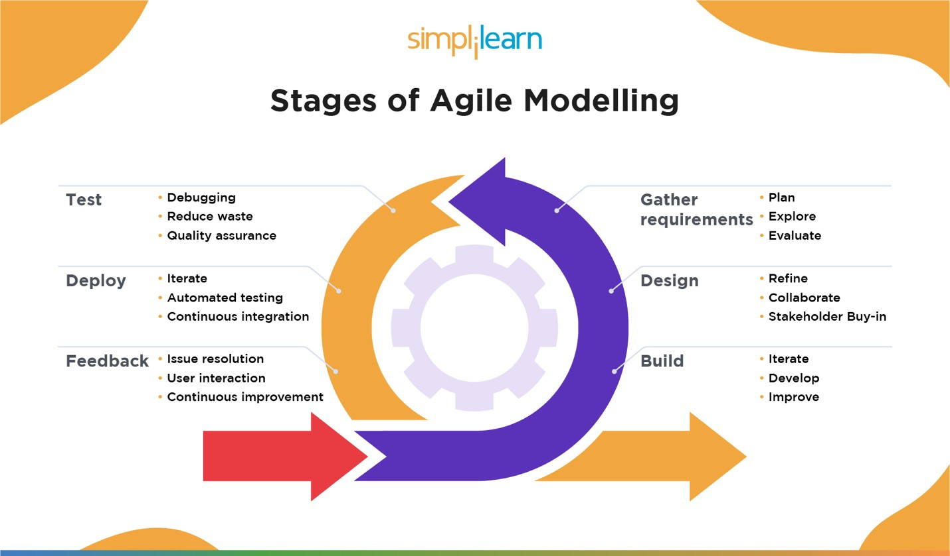

# Why Agile Development Model?

There are various reasons for picking this developmental model which are:

* Easily and Quickly Adaptable to Change: The customer needs can change from time to time. The development process does not require a lengthy documentation for adding some new features or requirements of the client. Any changes or new features will be added to backlog and will be allotted to the next iteration. Features will be added based on the priority and business needs.
* Testing minimizes risk: Using Agile method for testing, we will get feedbacks frequently which will help us to react on those feedbacks immediately. Developing the software in iteration will help us determine if we are on track or not. We will be sure that we are producing some value after every release as iterations are mostly done on the changes that the client needs in the application. Sprints are client-focused as they are mostly based on the reviews from the clients.
* Higher Quality Product: All the features are not added at once. They are added to each sprint which allows us to perfect those features so that they do not create any problems in future. It makes us ensure that each sprint provides some value because the application after each sprint is fully tested and working.
* Better Stakeholder Engagement: It helps in engagement of all the stakeholders in a better way as there will be scheduled meeting for the evasion of issues. All the differences or concerns will be sorted out.
* Greater Customer Satisfaction: The customer or the owner of the product gets satisfied as he is actively engaged to ensure all their needs are fulfilled. After every iteration, the customer will be pleased to see the working and fully tested final product.
* Better Control: This model helps everyone to work together. It helps to determine what goes next into each iteration. Daily meetings are scheduled for the same. There will not be any chances of unplanned feature into any sprint as everyone will be aware of what is upfront.

There are some disadvantages of using this agile developmental model which are:

* Limited documentation: Most of the documentation in agile approach happens throughout the development process, and often while adding some feature in a sprint, not in the beginning. This results in less detailed documentation which might become an issue in the future if the full documentation is required.
* No finite end: As there is very less planning required in this approach, there is never a clear vision on what the final product will look like. It is also easier to get some additional unexpected functionality because of less planning at the beginning.

Overall, we prefer using this model because at the end, everything comes to fulfilling the client’s needs as quickly as we can with correctness. It is best for our business as it reduces cost for development, and it is best for the team as it reduces time for development. This time will be wisely utilized to improve the performance and getting the reviews from the client. It will personally help every stakeholder to work peacefully with better engagement and lesser differences in the concerns.

# Conclusion

To conclude, agile development model is the most common development approach used in most of the mid-sized companies to large-scale companies. Agile approach follows a typical development process i.e., - requirement gathering and analyses, design, development, testing, deployment, and review or maintenance. Every phase has different strategy with different approach. Agile approach should be used because it helps in interactions between individuals over processes and tools. It also helps in customer collaboration, responding to change over following a plan, and fully tested and working software over many documentations. The agile approach also has some limitations of having no finite end and less documentation. Overall, the agile approach is to be considered because it reduces cost and time for development and also provides better engagement with the client and other stakeholders in the development.

# Bibliography

*10 reasons to use Agile software development*. (2022, June 2).

QualityLogic. https://[www.qualitylogic.com/knowledge-center/10-reasons-to-use-agile-](http://www.qualitylogic.com/knowledge-center/10-reasons-to-use-agile-)

software-development/

*The Agile software development life cycle*. (n.d.). Versatile & Robust Project Management Software | Wrike. https://[www.wrike.com/agile-guide/agile-development-life-cycle/](http://www.wrike.com/agile-guide/agile-development-life-cycle/)

*Blood products: Blood donation*. (n.d.). World Health Organization

(WHO). https://[www.who.int/news-room/questions-and-answers/item/blood-products-](http://www.who.int/news-room/questions-and-answers/item/blood-products-)

why-should-i-donate-

blood#:~:text=Why%20should%20people%20donate%20blood,and%20surgical%20and

%20cancer%20patients

*BLOODR: Blood donor and requester mobile application*. (n.d.). PubMed Central (PMC). https:[//w](http://www.ncbi.nlm.nih.gov/pmc/articles/PMC5682362/)ww[.ncbi.nlm.nih.gov/pmc/articles/PMC5682362/](http://www.ncbi.nlm.nih.gov/pmc/articles/PMC5682362/)

*Disadvantages of Agile*. (2022, September 29).

Planview. https://[www.planview.com/resources/articles/disadvantages-](http://www.planview.com/resources/articles/disadvantages-)

agile/#:~:text=No%20finite%20end,%E2%80%9Cfinal%20product%E2%80%9D%20loo

ks%20like

Editor. (2016, April 4). *Agile project management: Best practices and methodologies*.

AltexSoft. https://[www.altexsoft.com/whitepapers/agile-project-management-best-](http://www.altexsoft.com/whitepapers/agile-project-management-best-)

practices-and-methodologies/

*Google image result for HTTPS://imgv2-1- f.scribdassets.com/img/document/473716842/original/be7bb41ca9/1669725418'v=1*. (n.d.). https://images.app.goo.gl/nhmdyUhFWhhCuJtF8

*Google image result for HTTPS://s3.us-east- 1.amazonaws.com/static2.simplilearn.com/ice9/free_resources_article_thumb/Agile-01.jpg*. (n.d.). https://images.app.goo.gl/XffcFUVVRP16ET7i7

Kelly. (2022, January 31). *Design and development of blood donor app*. Krify - Web and Mobile App Design & Development Company in India & UK. https://krify.co/design-and-development-of-

blood-donor-app/

Milne, A. (2022, September 16). *The Agile development methodology explained*. Insights - Web and Mobile Development Services and Solutions. https://[www.netsolutions.com/insights/agile-](http://www.netsolutions.com/insights/agile-)

development-methodology/

*Redirect notice*. (n.d.).

Google. [https://w](http://www.google.com/url?sa=i&url=https%3A%2F%2Fwww.simplilearn.com%2Fagil)ww.googl[e.com/url?sa=i&url=https%3A%2F%2Fwww.simplilearn.com%2Fagil](http://www.google.com/url?sa=i&url=https%3A%2F%2Fwww.simplilearn.com%2Fagil)

e-modelling-

article&psig=AOvVaw1O9aTSL5F0npngQkr1vrJB&ust=1674062154081000&source=images&cd=

vfe&ved=2ahUKEwjx6bzRjc_8AhV6IDQIHRpIAtAQjRx6BAgAE

*US blood supply facts*. (n.d.). Donate Blood, Platelets or Plasma. Give Life | Red Cross

Blood. https://[www.redcrossblood.org/donate-blood/how-to-donate/how-blood-](http://www.redcrossblood.org/donate-blood/how-to-donate/how-blood-)

donations-help/blood-needs-blood-supply.html